further and higher spiritual unity of the  
*Sanctifier* and the *sanctified*, as evinced  
by his speaking of them. The same is  
plain from ver. 14 below: see there. So  
that it is the higher Sonship of God,  
common to the Lord and those whom  
the Father by Him is leading to glory  
which must be understood. See John viii.  
47; 1 John iii. 10; iv. 6; v. 19; 3 John 11.

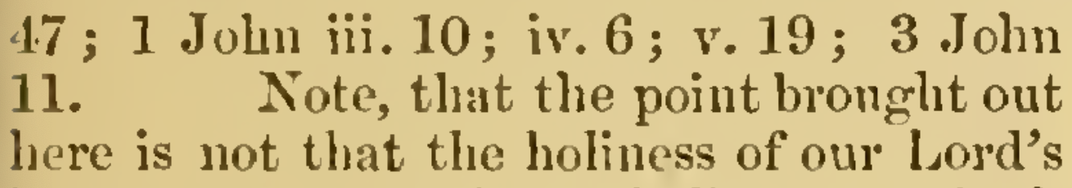

Note, that the point brought out  
here is not that the holiness of our Lord’s  
human nature, and our holiness, are both  
of one, viz. the Father [John x. 36]:  
which, however true, would be introducing  
a matter not belonging to the argument  
*here*), **all [of them]:** **on which account**  
(viz. because they are all of one) **He** (Christ:  
see above) **is not ashamed** (His consent in  
this relationship springs, as Chrysostom  
says, not from the nature of the case  
merely, but from His extreme love and  
condescension) **to call them** (that are  
sanctified) **brethren, saying, I will declare thy name unto my brethren, in the midst of the assembly will I sing of thee**  
(it will be sufficient to refer, respecting the general sense and prophetic import of Ps. xxii., to what has been before said, on  
Ps. viii. [above ver. 6], and on similar citations elsewhere. The Psalm was originally the expression of a suffering saint, in all  
probability David, communing with his  
God: laying forth to Him his anguish  
and finally triumphing in confidence of His  
gracious help and deliverance. But by the  
mouth of such servants of God did the  
prophetic Spirit speak forth His intimations respecting the Redeemer to come.  
No word prompted by the Holy Ghost had  
reference to the utterer only. All Israel  
was a type: all spiritual Israel set forth  
the second Man, the quickening spirit: all  
the groanings of God's suffering people prefigured, and found their fullest meaning in, His groans, who was the chief in suffering.  
The maxim cannot be too firmly held, nor  
too widely applied, that all the Old Test.  
utterances of the Spirit anticipate Christ,  
just as all His New Test. utterances set  
forth and expand Christ: that Christ is everywhere involved in the Old Test., as He is every where evolved in the New Test. And this Psalm holds an illustrious place among those which thus point onward   
to Christ. Its opening cry, “My God, my  
God, why hast thou forsaken me?” was  
uttered by the Lord Himself in His last  
agony. The most minute particulars detailed in it are by the Evangelists adduced as exemplified in the history of His Passion; see e.g. John xix. 24 And, as Bleek well observes, the particulars chosen  
out of that history by St. Matthew seem to  
have been selected with an especial view  
to the illustration and fulfilment of this  
Psalm. Ebrard, in his note here, insists on  
the authorship of the Psalm by David, and  
on its date, as belonging to the time of his  
persecution by Saul, Then he maintains  
the exact parallelism of the circumstances  
with those of the second and greater David,  
and refers the *“brethren”* here to the countrymen of David, who were hereafter to be his subjects. I have no positive objection  
to this view. Subordinately to the deeper  
and wider one, it might be applicable in  
individual instances: but that other seems  
to me both safer and nearer the truth.  
The particular verse here chosen, the 22nd,  
forms the transition-point from the suffering to the triumphant portion of the Psalm: and consequently the resolution  
expressed in it by the Messiah has reference to His triumphant state, in which he is still not ashamed to call his people  
brethren. It is characteristic of the object  
of this Epistle with reference to intended readers, that whereas the Writer might have cited two instances as matters  
of fact, in which our Lord did call His  
disciples brethren after His resurrection  
[see John xx. 17; Matt. xxviii. 10], yet he  
has not done so, but has preferred to establish his point by the Old Test. citations).

**13.] And again, I will put my trust in Him** (there is considerable dispute as to the original place from which this citation  
comes. Most Commentators, and recently  
Bleek and Delitzsch, have believed it to be  
taken from Isa. viii. 17, where the words